Algorithm for file updates in Python

Project description
This project is to create an algorithm to keep updated a file that identifies the employees who can access restricted content. The contents of the file are based on who is working with personal patient records. Employees are restricted access based on their IP address. There is an allow list for IP addresses permitted to sign into the restricted subnetwork and a list of ip addresses that should not be able to access those data.

Open the file that contains the allow list
Firstly, you want to give the file a proper name to be used later, then to open the file you need to use the the with statement and the open function to open the file, insert the file name as the first parameter and as second parameter the “r” parameter, that means to open the file and read it, and then outside of the parentheses to make change the name of it to file
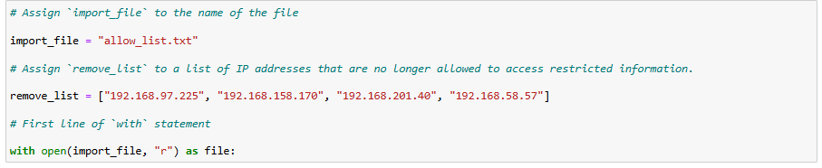

Read the file contents
To read the file content, you need to use the .read () to read the file and import it to another variable to print it
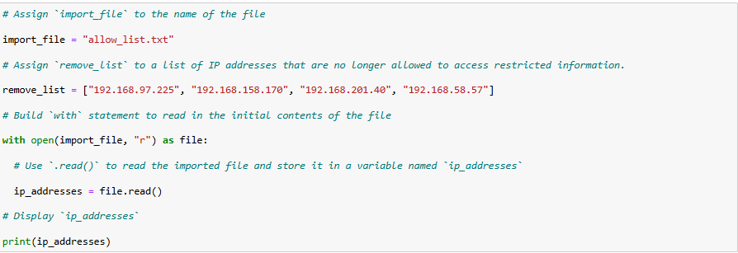

Convert the string into a list
By using the .split() method , the string converts into a list, dividing every ip address by commas, making it more easy to read.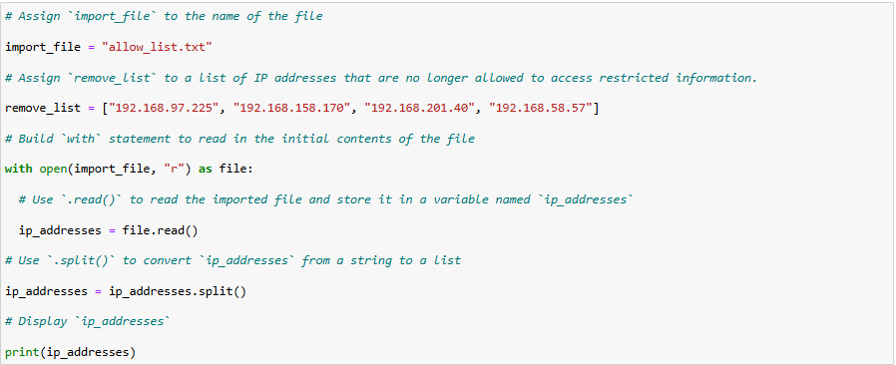

Iterate through the remove list
By using the for loop to create an iterative statement that goes into the element loop variable that is gonna search in ip_addresses the “element”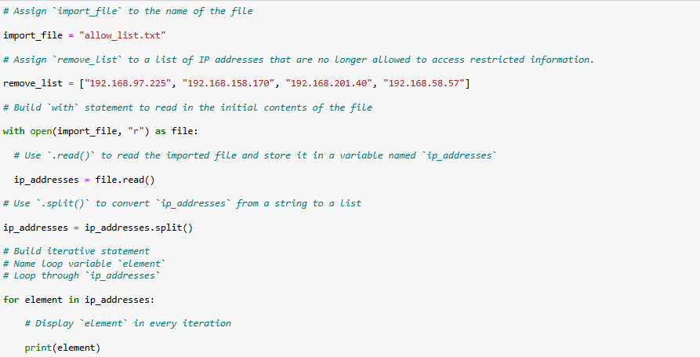

Remove IP addresses that are on the remove list
Now, by using the if statement, if the element (in this case the remove_list content) is also in the ip_addresses file, the algorithm will remove the addresses flagged by the remove list 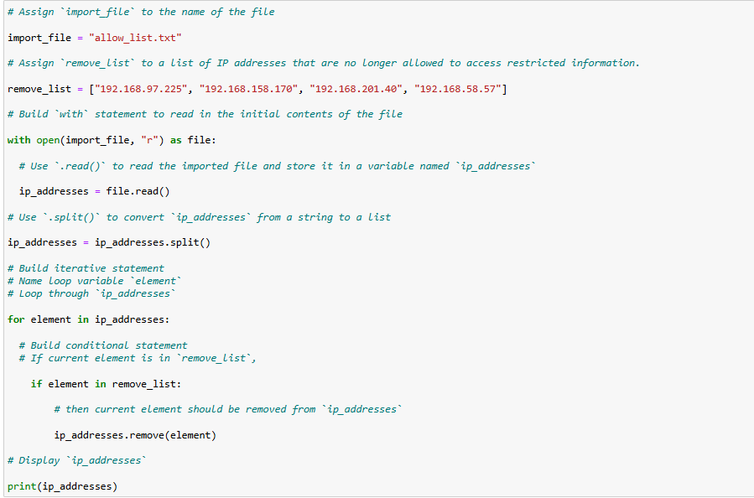

Update the file with the revised list of IP addresses
After deleting the ip addresses flagged in the ip_addresses variable, we have to change again the format of the ip_addresses from a list to a string by using .join(), with “ “ that means a spacebar in between parts of the list, then open the ip_addresses with the “w”argument to let me write on the ip_addresses and calling it file. After that can use the .write that writes string data to a specified file and replaces any existing file content.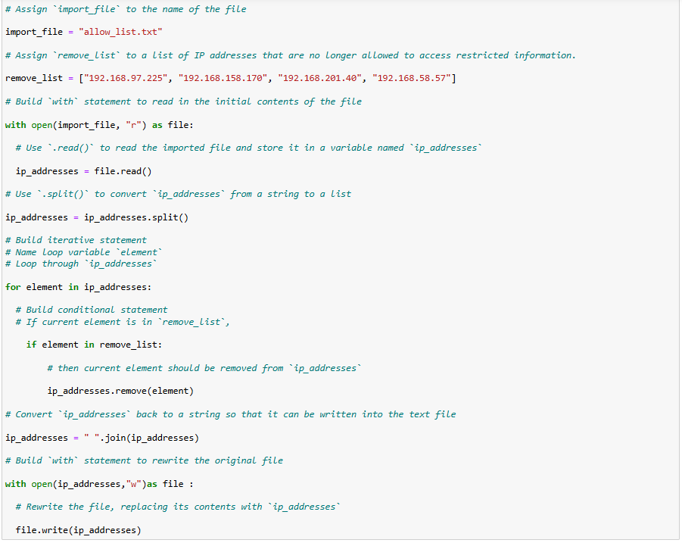

Summary
In this project i created an algorithm that removes the flagged ip addresses stored in the remove_list variable and removes them from a text file by using the with statement, the .remove() and .split() and the .join() methods to remove the ip_addresses and transform the string into a list and vice versa.

